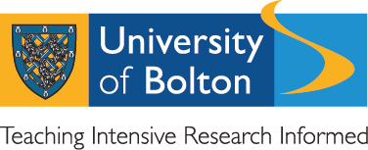
2017-18 Annual Report - UUK Concordat to Support Research Integrity
The University of Bolton supports the Universities UK Concordat to Support Research Integrity
The UUK concordat seeks to provide a comprehensive national framework for good research conduct and its governance. As signatories to and supporters of the concordat to support research integrity, we are committed to:
- maintaining the highest standards of rigour and integrity in all aspects of research
- ensuring that research is conducted according to appropriate ethical, legal and professional frameworks, obligations and standards
- supporting a research environment that is underpinned by a culture of integrity and based on good governance, best practice and support for the development of researchers
- using transparent, robust and fair processes to deal with allegations of research misconduct should they arise
- working together to strengthen the integrity of research and to reviewing progress regularly and openly
The full supporting document can be found here:
http://www.universitiesuk.ac.uk/policy-and-analysis/reports/Documents/2012/the-concordat-to-support-research-integrity.pdf
Formal Investigations of Research Misconduct in the Context of the Concordat.
In 2017-18 (August 17 to July 18) there were no reports or investigations of research misconduct at the University of Bolton.
Point of contact for further information on matters of research integrity, the UUK Concordat and related matters:
Dr Andy Graham, Executive Dean, Research and Graduate School, University of Bolton, 01204 903220, a.graham@bolton.ac.uk
Any person wishing to raise concerns about the integrity of research being conducted at the University of Bolton should consult the University’s Public Interest Disclosure Document:
https://www.bolton.ac.uk/wp-content/uploads/2018/02/Public-Interest-Disclosure-Policy.pdf

