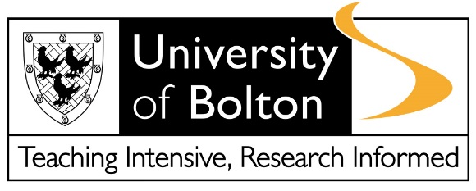
CONFIDENTIAL: OFFICE USE ONLY
FORM D: Risk Assessment Interview Record
Name:
Provisional Student Number:
Date of Birth:
Course applied for:
Time and Date of Interview:

Please keep a detailed record of the interview including the questions asked and the responses given. Example interview questions can be found in Appendix 1 to this form at www.bolton.ac.uk/admissions/disclosure
1
2
3
4
5
6
7
8

Consent for Sharing of Information
I understand that the information gathered at this meeting and recorded will be shared with the key staff at the University involved in carrying out the Risk Assessment.
I understand that I may be asked to carry out activities to reduce the risk posed by me in terms of my criminal convictions and to assist and support me during my time at the University.
Data Protection and Disclosure of Personal Information
I understand and acknowledge that the University of Bolton will process the personal data contained in this form, or other data which the University may obtain from me or other people. I acknowledge the processing of such data for any purpose connected with my enrolment, my health and safety or for any other legitimate and lawful reason.
The University will hold and process your personal data in compliance with our obligations under the General Data Protection Regulation and Data Protection Act 2018 and in accordance with our Data Protection Policy and Privacy Notices available at: https://www.bolton.ac.uk/about/governance/documents/#dataprotection

Applicant Signature:
Print Name:
Date:

Interviewer Signature:
Print Name:
Date:

