Careers and Employability Team
The Careers Service is here to help you! We are here to listen. We care about your future. We want to help you to achieve your career goals.

At the University of Bolton, we offer you more than just careers advice. We want you to achieve career success and we will help you every step of the way, providing you with employability experiences that will enhance your CV and boost your skills.

Whether you are studying on a full-time or part-time basis, or you are an undergraduate or postgraduate student, we offer a range of careers and employability support adapted for your individual needs. We can help you with exploring your career options, applying for job vacancies, writing a CV and covering letter, finding a work placement and developing those skills and attributes that employers look for.

Your Careers and Employability Team
The Careers and Employability team is made up of people with an incredible amount of careers guidance and recruitment experience who can help you to plan your future career. We are a small and friendly team based within the Student Centre, off Chancellor’s Mall.

How to meet us
You can pop in to see us in the careers office which is located within the Student Centre. Our opening times are Monday to Friday, 8.45 – 5.00pm. If you are struggling to get onto campus then you can ring us on 01204 903080, or email us at studenthub-careers@bolton.ac.uk

What we do
We seek to equip every Bolton student with the skills, knowledge and confidence to find and make the most of their opportunities and we work with your Academic Departments to provide career development within your course.

At each stage we also offer a range of other exciting events and activities to build skills and experience to help you to stand out from the crowd. Some of the support on offer includes:
- Information on different career paths
- Information on a range of job opportunities both nationally and locally
- The opportunity to gain a range of employability skills and graduate attributes
- The chance to build your contacts and networking opportunities
- The chance to explore self-employment opportunities
- Support to complete application forms, CVs and covering letters
- Support to find placements, internships, graduate vacancies and postgraduate courses
- A range of resources and career guides that will help you in your job search

Develop your skills
During your time at the University of Bolton, you will find lots of opportunities to develop your skills, both in the curriculum, and also through extra-curricular activities. Being able to showcase your skills to future employers will give you a far greater chance of beating off the competition, when it comes to that final job interview.
The University of Bolton has developed the Graduate Attributes Matrix for Employability (GAME) which provides an overview of the key skills it expects all graduates to leave University with.
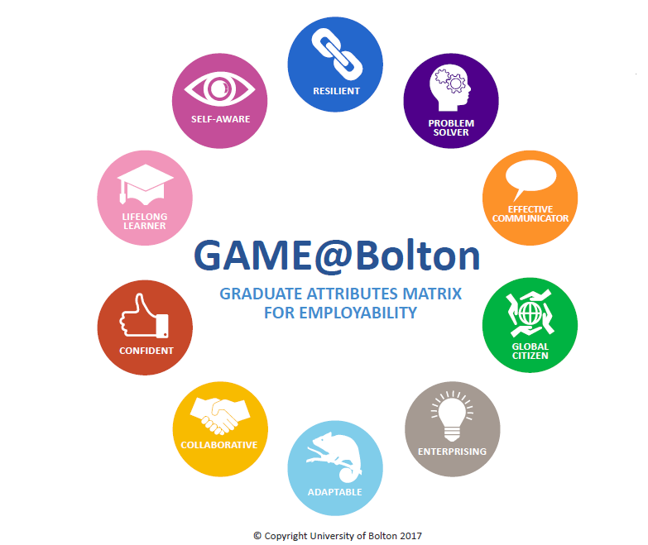

GAME is use by the Careers Team to help you self-assess where you are in terms of employability skills and attributes. This model will be used to assess your professional development during your time at University, and provide you with a foundation for the start of your career.
We will help you to consider your USP (unique selling point). We will help you to understand what your unique strengths, skills, attributes, attitudes and experiences are, and this will ultimately help to distinguish you in the job market.

Work Experience
In an increasingly competitive graduate job market a good degree is not always enough to secure the job that you want when you graduate. Experience is critical!
As well as looking at your academic achievements, employers will want to see evidence that you have developed a range of skills that will be beneficial to them.

One of the most useful and beneficial ways of doing this (and helping you to decide on the types of jobs that you want to apply for after graduation) is by gaining work experience.
Work experience provides you with the skills and exposure that will allow you to stand out to potential employers and is a crucial part of becoming ‘workplace-ready’.

To help you find the right work experience, each School has a linked Employer Engagement Consultant, whose job is to work directly with employers and industry. They are there to support you through the process, and introduce you to a placement that is going to provide you with vital skills to add to your CV.

Bolton Award – An Extra-Curricular Programme
The University runs an extra-curricular Award programme that will allow you to build your skills and knowledge. It is voluntary and can be undertaken at any point, whilst you are at University.

What is it?
- An employability programme designed to give you work experience and help you to develop those all-important skills that employers look for.
- A flexible programme which allows you to start at any time of year, whether you are a first year undergraduate or a PhD student.
- A programme that allows you to work at your own pace, so you can finish it within 3 months or take the full 3 years.

What do you need to do?
- Complete 35 hours of employability activity such as part time work, volunteering or Student Union Society participation (your current experience counts!)
- Come and meet one of the Careers Advisers to discuss your career goals and plans.
- Attend 5 key employability workshops which include understanding graduate routes, CV writing, application forms, interview practice and understanding LinkedIn.
- Write a CV, reflective statement and attend a mock interview.

What do you get out of it?
- Extensive access and support from our professional careers team to develop those crucial employability skills that will help to land you that perfect career.
- The chance to meet new employers and contacts who can help you to reach your goals.
- The opportunity and support to gain new work experience to bolster your CV.
- The chance to meet new people and take advantage of opportunities you may never have thought were possible.
- A fully recognised achievement that is verified by the University of Bolton which can appear on your Higher Education Achievement cord (HEAR).

