

**WELCOME TO CLEARING 2020**

**Clearing on the Web Training and Reference Notes**

**Please retain a copy of these notes for your session on the clearing hotlines.**

**If you have any problems attending your allotted clearing session please arrange cover from within your Academic Group or Department.**

**Contact during Clearing:**

**Paul Starkey,**

**Director of Recruitment & Admissions**

**01204 903138 or 07880722205**

**p.starkey@bolton.ac.uk**

**PLEASE REMEMBER**

Staff are making ‘recommendations’ for offers on courses, only the admissions team can make official offers onto the courses once all qualifications and statuses have been checked.

Most applicants will be applying with qualifications obtained under the “new” UCAS tariff introduced in 2017 but please be vigilant when assessing points. We must be really clear and clarify with the student what they have achieved and when, to ensure applicants are offered an appropriate course.

Please do not disclose our entry points to any applicants, ask them what qualifications they have and we will look if they are eligible for any of our courses, even if they are persistent.

Clearing callers cannot refer via UCAS Track on Thursday 13th August until 3pm.

Callers will automatically be provided with email instructions following the call.

Good News Stories and latest rankings will be displayed in the room, please ensure we use these as often as we can.

**Logging in to Clearing on the Web (COW)**

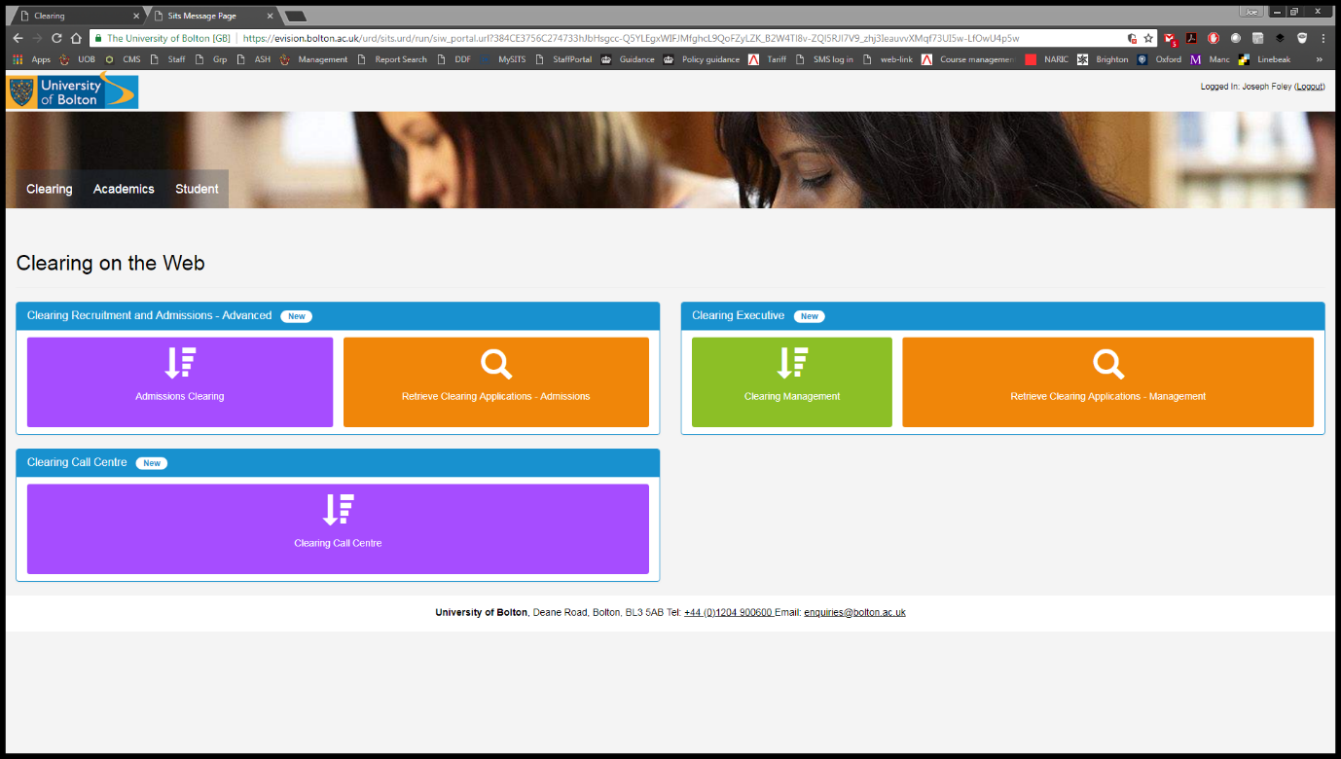**Clearing on the web functionality is improved using Chrome as the browser. Go to** [**https://evision.bolton.ac.uk/urd/sits.urd/run/siw_lgn**](https://evision.bolton.ac.uk/urd/sits.urd/run/siw_lgn) **and login with your normal staff ID. If you do not see Clearing on the Web automatically, click the Clearing Tab, then the Clearing Call Centre button.**

**Welcome Screen -** The first screen you will see is the ‘Welcome’ Screen. This is where we will “triage” enquirers.

[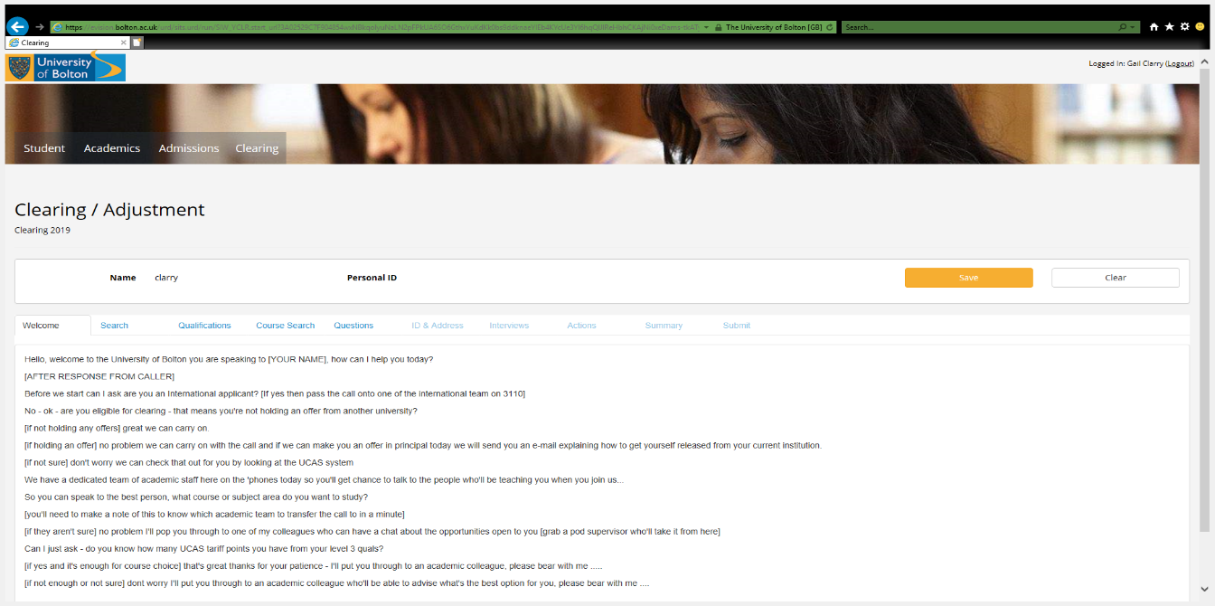](https://evision.bolton.ac.uk/urd/sits.urd/run/siw_yclr.start_url?3a02529c7f904854wxnbkqolyunaln2pfpkua6so6gthxyukdkk0bs9ddknaeyieb4kycue3yi6hqqljirehbhckajni0xedams-tkatyc1hpn71w9plj6otqf8leaa9dfyvpjuoxhlmtds8ddnohx29ptdtjukd_0kefwzym7sc7noj5q5t_cueny5cakpoeqyyhucmukxspfraqi68ka-qe-a6lobbimih5-9xmpgvs8pa83tqm_mizzw5cyz5lhykovjp--sfgen4q-e8g_9kflhkli0hp9q7lcss7_wiaoybxzfurrz-hci#1)

***Hello, welcome to the University of Bolton you are speaking to [YOUR NAME], how can I help you today?***

**At this point, also find out whether they are Home or International.** **If they are International, try to put the applicant through to the International Officers to discuss the caller’s eligibility to study with us (ext3110). If they are not available please take a name and number and pass to the international team for a call back.**

Callers will probably ask whether we offer the course or area of study that they are interested in. All callers should have been on our course finder to ensure that their area of study is offered here before calling. - If they aren't sure of a course direct the caller to **www.bolton.ac.uk/clearing**

**IMPORTANT: Any courses that have been closed for Clearing will be listed on the whiteboard in the room you are in.**

[AFTER RESPONSE FROM CALLER] ***OK, are you eligible for clearing - that means you're not holding an offer from another university?***  [If not holding any offers] ***great we can carry on.***

[If holding an offer] ***no problem we can carry on with the call and if we can make you an offer in principal today we will send you an e-mail explaining how to get yourself released from your current institution.***

[If not sure] ***don't worry we can check that out for you by looking at the UCAS system***

***We have a dedicated team of academic staff here on the 'phones today so you'll get chance to talk to the people who'll be teaching you when you join us...So you can speak to the best person, what course or subject area do you want to study?*** [You’ll need to make a note of this to know which academic team to transfer the call to in a minute]

**You may wish to take a note of the enquirers name and number and subject of interest at this point in case you accidently get cut off. Jot it down on a piece of paper.**

**I will now transfer your call through to the appropriate member of academic staff. (If applicable)**

**Search**

**IMPORTANT: Please ensure you are speaking to the applicant in person i.e. not their parent or other interested party unless the applicant is present and can give you express permission to continue with the third party.**

**UCAS applicants**

Ask if the caller is in the **UCAS** system and is eligible for Clearing. If the caller is unsure, ask if they have received a 6 digit **Clearing Number** (we don’t need this, it just confirms that they are in Clearing). If they are not eligible or not sure we can carry on with the call and if we can make a recommendation for an offer instructions on how to be released from their holding institution will be included in the e-mail they receive from us.

If the caller isn’t in UCAS and wishes to make a **direct** application, still continue with the call.

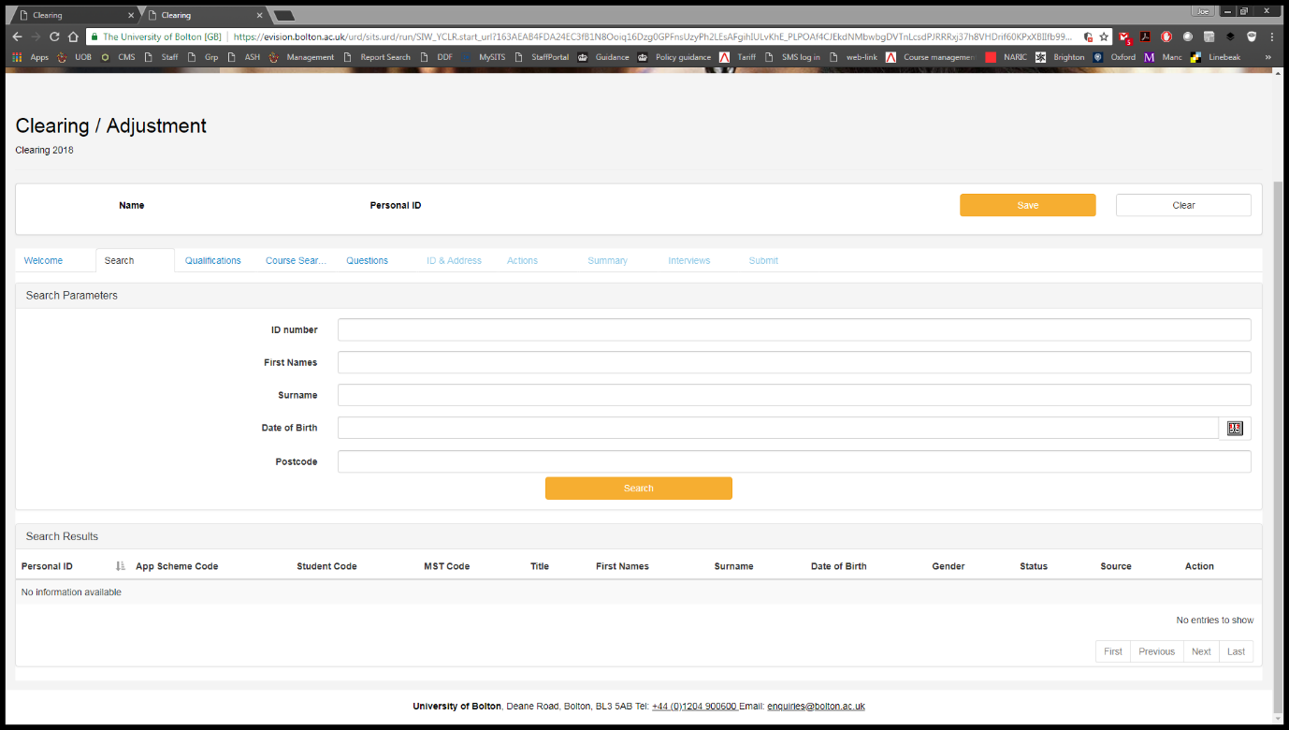**UCAS –** Ask the applicant for their10 digit Personal ID and enter it in the ID Number field

Then click the **Search** button

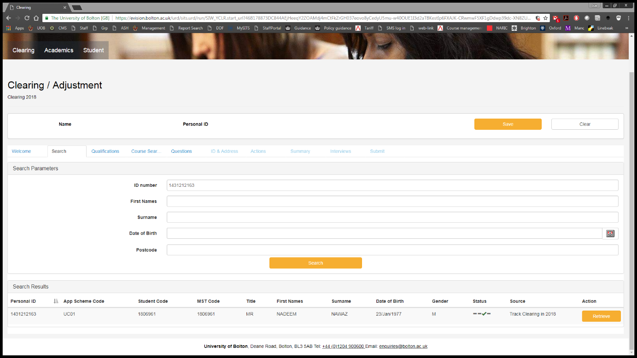The applicant’s details should be displayed on the screen, click Retrieve at the right hand side of the record and you will be moved automatically to the **Qualifications** tab**.**

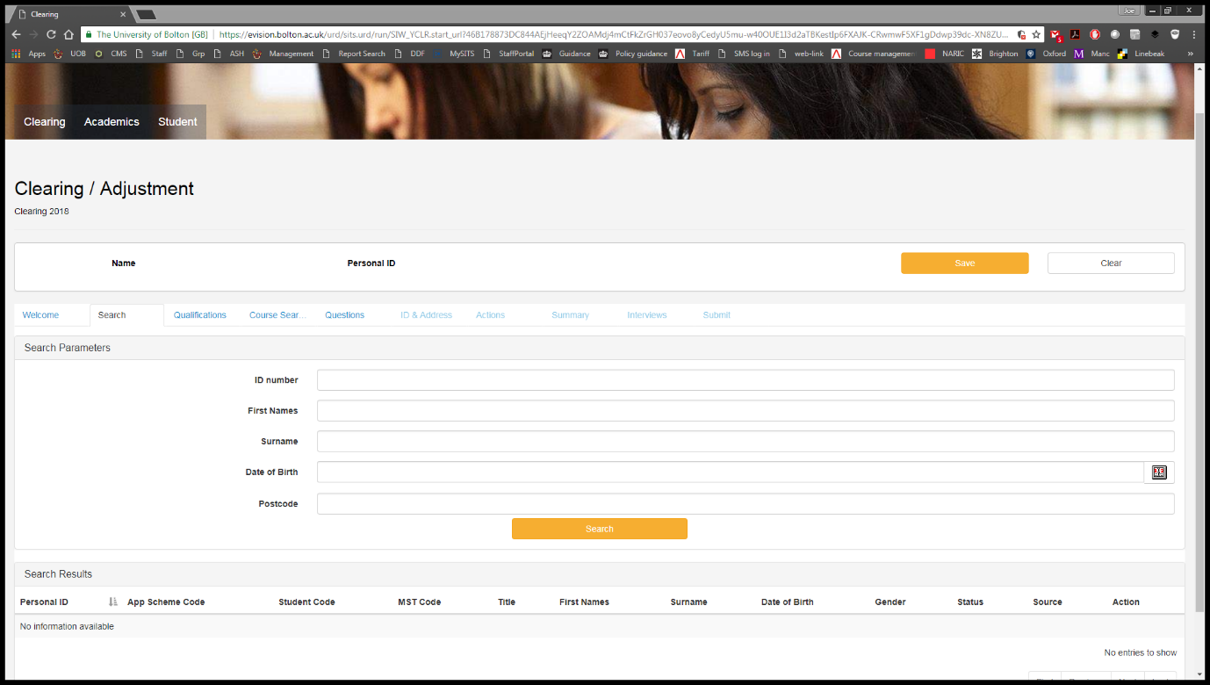If the **Personal ID** isn’t available, it is possible to search using this screen, by entering **Forename, Surname and Date of Birth** then pressing the Search button.

A list of potential matching applicant’s will be displayed, click Retrieve at the right hand side of the **correct** record.

Verify with the caller you have the correct record by checking their DOB.

**If there is no match, continue the call by clicking the Qualifications tab. Additional personal information can be collected later in the call.**

**Direct applicants**

For Direct applicants it is possible to search by entering **Forename, Surname** and **Date of Birth** then pressing the Search button, as above. If there is an exact match, click Retrieve as with UCAS applicants. **As above, if there is no match, continue the call by clicking Qualifications.**

**Click the Qualifications tab.**



**Qualifications**

In Qualifications, we take details of the caller’s Level 3 or relevant qualifications.

Press the Add Qualification button to make the options appear.

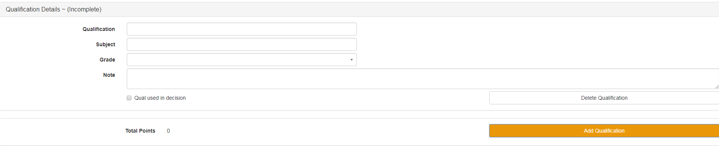

For each qualification:

* Search for the qualification – if it suggests a match, click it to populate (You will need the hyphen in A-Level, A Level will not work). All popular Level 3 qualifications are included, so if you can’t find it, please ask your Pod Supervisor.
* BTEC qualifications are a little complex so most have included the relevant number of grades next to the description, ie 1GD, 2GD, 3GD etc
* **Please note, if you click the suggested Qualification, it will change to display the code on the left, in this case “NTA”.**



* If the Qualification does not show, tab to continue to Subject.
* Search for the Subject – again, if it suggests a match, click it to populate (this will populate the code as above). If the Subject does not show, tab to continue to Grade.
* If you have used a suggested Qualification you can select a Grade from the dropdown list and points will be added automatically.



* If you are adding a bespoke Qualification, you can enter the grade manually if it doesn’t display. You may wish to add any notes to the Note field if they seem relevant.
* To add another Qualification click the Add Qualification button.
* Once complete, click the **Course Search** tab.

**Course Search**

Now you have input the applicant’s qualifications, the Course Search page will show you which courses they are eligible for.

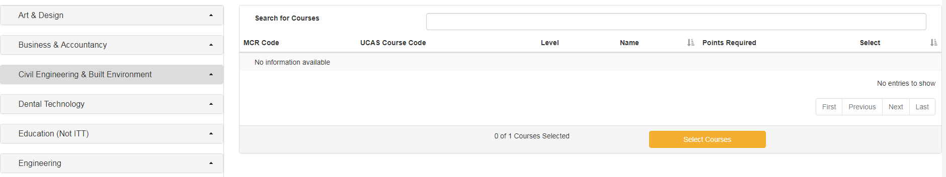You can either search in the Search for Courses box, or expand the Subject Areas in the left column to find which courses we offer.

Searching for the word “Sport” will show the following.

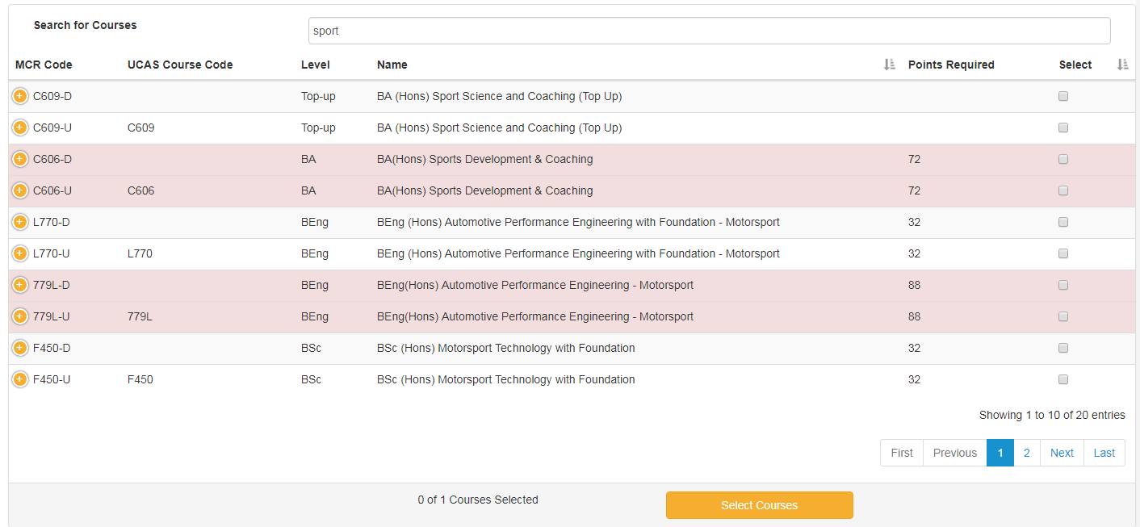

Or using the Subject Areas on the left, you can expand to show a list of programmes, which can then be selected to show in the list.

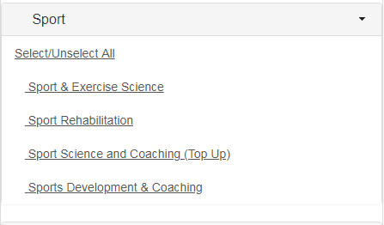

Selecting Sport Rehabilitation will show the following.

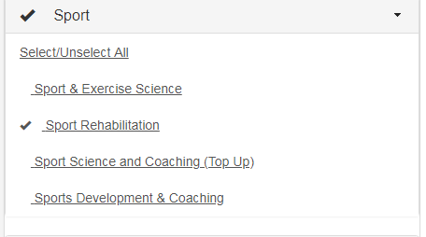

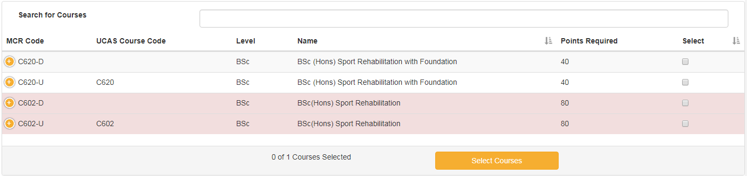

A list of all available courses that the applicant is interested in within the selected subject area will be displayed.

You will notice that some courses are highlighted in red. The applicant is **NOT** qualified for this course. They did not meet the Points required with the Qualifications added on the previous screen.

If you are not the course tutor, check to see if the chosen course is on “Courses Requiring Interview” list [A1 Poster on Wall]. If so advise applicants that will get a call back from an academic in their chosen field.

**IMPORTANT: At no time disclose our entry requirements (points) to the caller – they may not be who they claim to be, i.e. journalists or mystery shoppers from other institutions masquerading as applicants**

Each course will have a different course code depending on whether they are UCAS or Direct. Please ensure you select the correct course. A UCAS course will end in –**U**, and a direct course will end in –**D**.



The example above shows an applicant who would qualify for a course, with both direct and UCAS courses listed -

When you are **absolutely certain** you have the correct course, tick the box in the Select column, press Select Courses, and the course you have selected will be highlighted in blue.

Once course selection has been made and confirmed it cannot be undone – you will see a pop up to advise you of this.

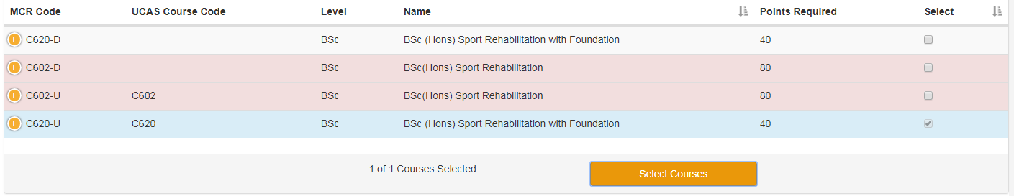

Click the **Questions** tab to continue the call.

**Questions**

On Questions we must ask the applicant a series of standard questions before we can continue with their application. All questions are mandatory

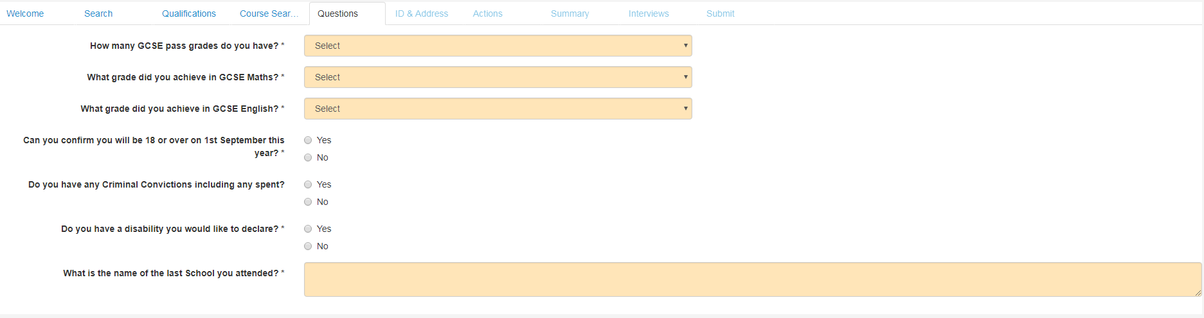

Q4 - Should they answer **No** to the question regarding if they will be 18 or over on 1st September, please advise them that any recommendation of an offer is subject to a risk assessment. Admissions will contact them with further information. Please continue with the questions.

Q5 - Should they answer **Yes** to the question regarding Criminal Convictions, please advise them that any recommendation of an offer is subject to our Criminal Conviction checking process. The Admissions Team will contact them with further information.

**Once the final Question has been populated,** press tab in order for the ID & Address option to show in the navigation bar. Click the **ID & Address** tab to continue.

**ID & Address**

On ID & Address, we must collect accurate contact details for the applicant. Some may be pre-populated depending on whether the applicant is UCAS, or if they have applied to us previously.

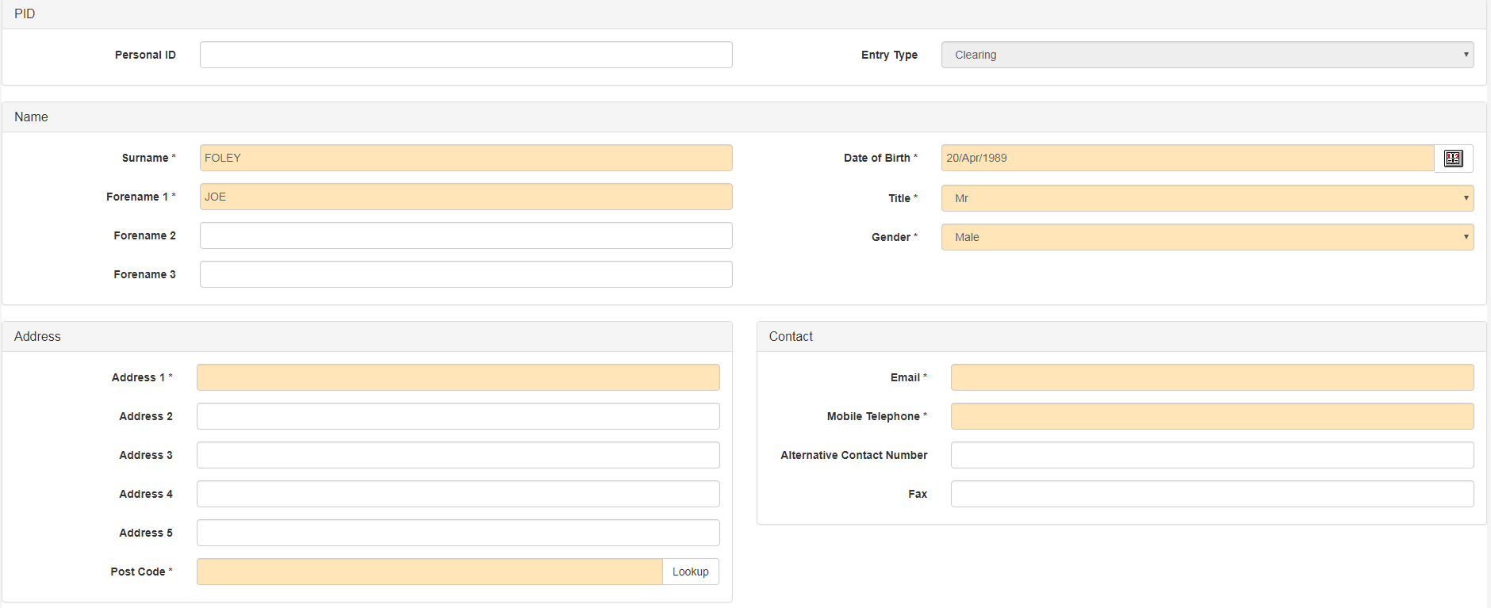

* Recheck the applicant's names
* Recheck their date of birth
* If the applicant’s address is missing type their postcode in the postcode box, then click **Lookup**. This will launch the Address Lookup. Select the appropriate address from the list and click on it. It will auto populate the address fields.

Please ensure all details are current – they may have changed for UCAS applicants or if they have previously applied.

Mobile number and email address fields are mandatory so please **recheck the spelling of the email address**. This is extremely important information – without it we will not be able to contact the applicant and they will not receive any instruction on how to refer.

Landline numbers should be input into the alternative contact number box.

All orange fields are mandatory, but please try to collect as much information as possible!

**Please press the orange Save button at the top of the screen then click the Interviews tab.**

**Interviews**

There will be a list of interviewing courses on the wall in the main tree rooms.

Please note if you are taking a call for an interviewing course and you are not from that department, you do not need to book the interview, the admissions team will pick this up from the action you will store later (see notes on Actions page).

**Open Days**

Applicants can be advised to book an Open Day via our website (bolton.ac.uk/opendays). Links will be sent via email once the call is complete.

**Please press the orange Save button at the top of the screen before moving to the Actions tab.**

**Actions**

This is where recommended actions are identified and stored according to the type of enquiry.

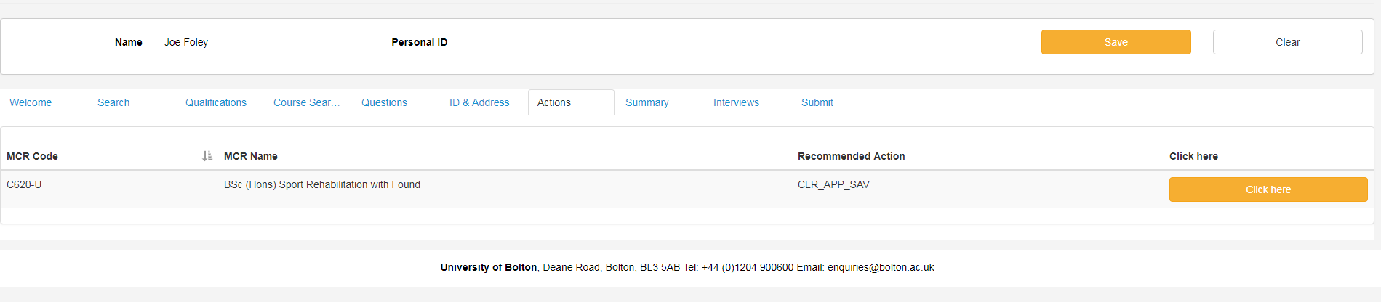

On the actions screen, press the Click Here button to open the Actions box.

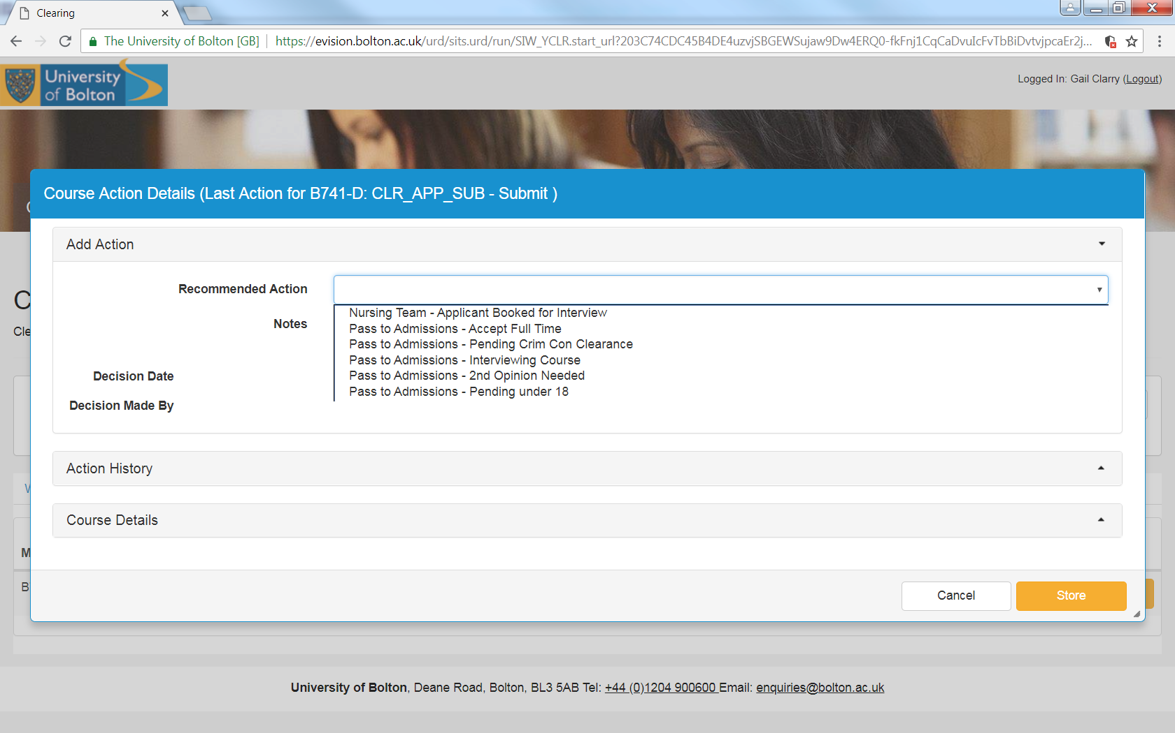

Select the appropriate action from the drop down list, hopefully most should be **Pass to Admissions – Accept Full Time** apart from courses which need an interview.

For interviewing courses where you are not from the relevant department select **Pass to Admissions – Interviewing Course.**

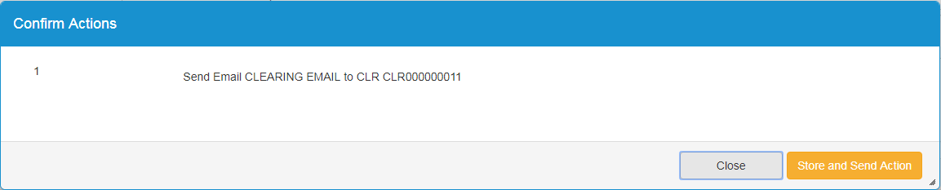Press **Store** and you will be asked to confirm the action. If you are confident that the action is correct, press **Store and Send Action**

This will allow the Admissions team to see the details of the call including your recommended action.

Click the **Summary** tab to continue.

**Summary**

You will now be presented with the Summary screen. This may change depending on the action selected on the previous screen.

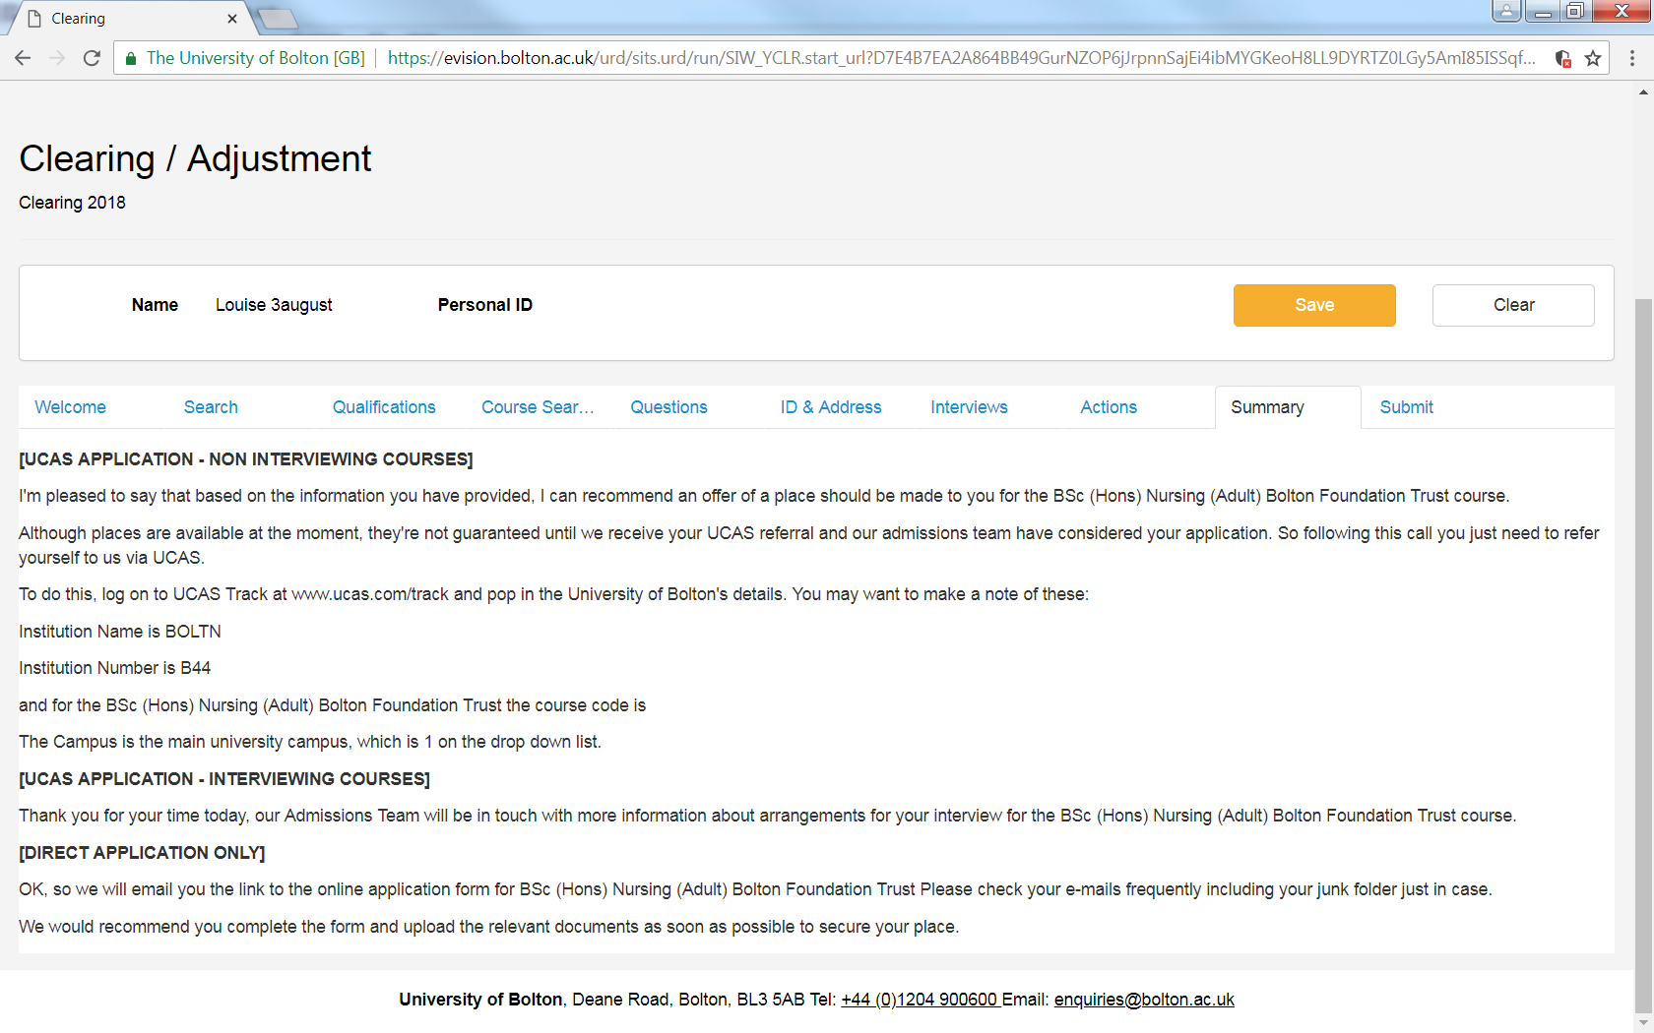

Click the **Submit** **tab** to continue.

**Submit**

The Submit screen is the final part of the call.

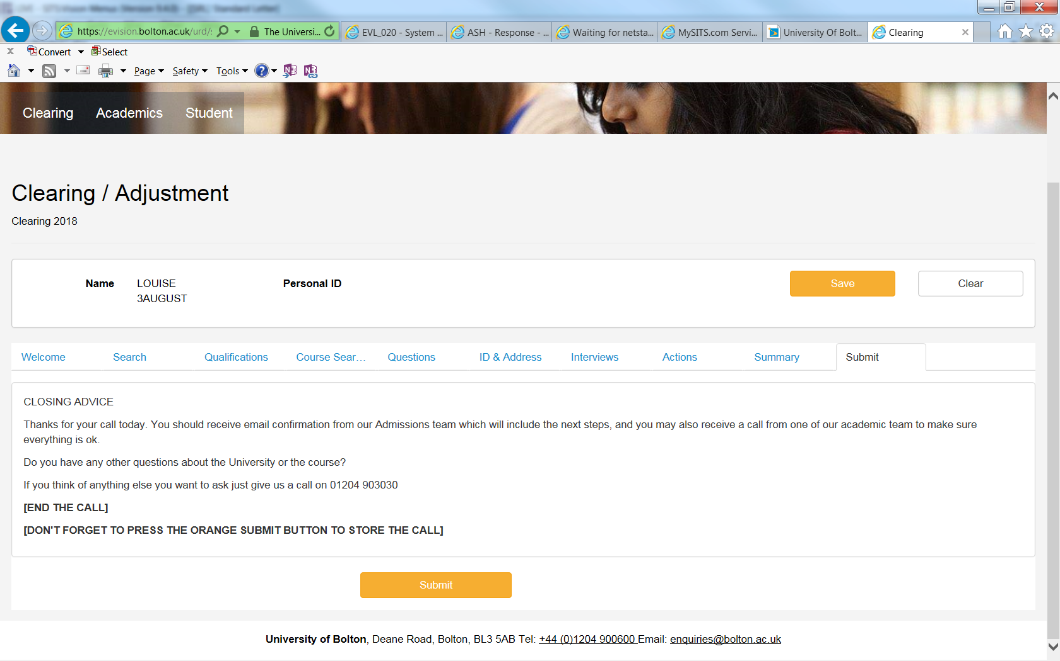

**Please press the orange Submit button or the information will not be stored.**

The confirmation box should appear to advise the record has stored:

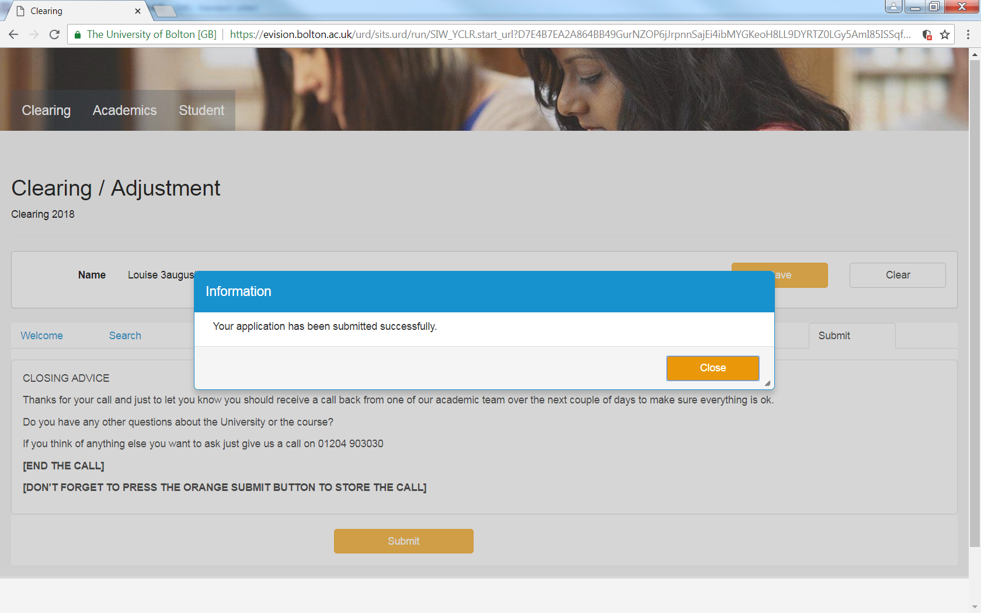



Close this, and press to start a new call.

**Please see next page for information on UCAS track.**

**FOR INFORMATION - How the applicant adds the choice in Track:**

* in the choice details screen the applicant needs to select the provider.
* to add the course details – the applicant needs to select ‘Other’ as the course choice and will then be presented with a box to enter the course code (see below):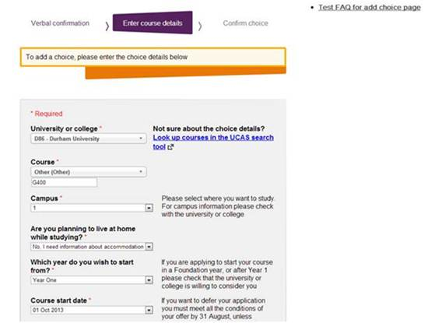

***“Please release me”***

Applicants can self-release from their firm choice.

Self-release has been given a soft launch by UCAS so may not be widely known about.

This means that instead of having to contact their chosen university and wait to be released into Clearing, applicants can now do this themselves. Online self-release is available via UCAS Track to all placed applicants.

**How online self-release into Clearing works**

The process is simple, but incorporates a number of warnings to make sure applicants fully understand what they are doing.

* **The applicant signs in to Track, and clicks the ‘Decline my place’ button on their homepage.**
* **They will be taken to a page which explains what they’re about to do, and a drop-down question which they must complete, before confirming.**
* **They will then receive an email to confirm they’re in Clearing, and advising them to phone the university or college they declined, if they made a mistake.**

Anyone wanting to be released from UoB should be advised to self-release and not referred to admissions. The mailbox used for this purpose in previous years has been decommissioned.